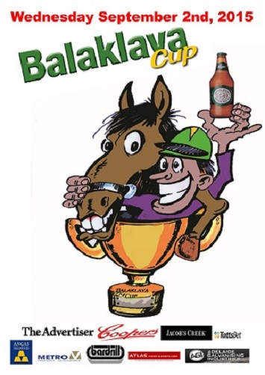

Email to all Vic and SA Trainers on 24th August
Balaklava Cup 2nd September
Trainers $20,000 cash bonus.
BALAKLAVA CUP (L.R.) 1600m $100,000 Nominations close at noon Thursday 27th August for the Balaklava Cup meeting 2nd Sept. $20,000 Cash Trainers Bonus for any trainer that can train the Cup and Sprint ($50,000)winners. (conditions do apply)
For full details contact Balaklava Racing Club on 088 862 1503 or TRSA 088 179 9812.

